

CONURBANT Kick off meeting, Vicenza May 30/31, 2011
INSTITUTIONALISATION
SURVEY
The istitutionalisation of SEAPs

Partner Municipalities involve all their departments, their politicians and their conurbation towns in a survey of energy-related policies

The cooperative analysis of the results is necessary to understand how to integrate energy-related policies and programming tools and to develop a Municipal cross-cutting energy policy strategy, involving all sectors and the political opposition

This is necessary to create the base for the Municipal institutionalisation of SEAPs once they are developed and to guarantee their sustainability in the future

….a participated action planning process enter the political sphere of the Municipality…
….to make the results of the process being approved by the Municipal Council and influence the following policy-making decisions.

Institutionalisation, therefore, means for a Municipality to use a SEAP to ‘go out’ and reach out for the territory in a stable and monitorable way

The aim of this workpackage is to provide Trainee cities, but also Trainer cities, with a clearer view of the current energy-related policies that exist or that are being discussed at local level, sector by sector, department by department

WP2 is necessary for collecting information and taking decisions useful for carrying out the successive activities in the best way

Tools such as questionnaires, spreadsheets will be produced to facilitate homogeneous data and information collection

Surveys and interviews with politicians, technicials, officers will be carried out at local level

1. Surveys Preparation

1.1
common tools will be prepared for collecting data and information which will be useful to define the Municipal strategy in the following tasks.

When they are ready, they will be presented to the auditors of the partners participating in the surveys.

a common template for the analysis and comment of the surveys will be provided. In this way the final deliverable “Report on cross-cutting, energy-related policies in Municipalities” will be well balanced and clear

2. Carrying out the Surveys (leader STRATAGEM) - ACTIONS

Visit or call by phone the selected targets for filling in the questionnaires (or focus groups or audits?)
Identifying gaps in information, as some data and information might not be available during the interviews
Guiding the information collection (to get all necessary informations)
Analysing and comment of questionnaires (Assessment)
Peer-to-peer discussion of results during MM2. Integration of the information and sharing of good practices presented by the WP leader thanks to EU sources, such as the results of the “SURVEY on Sustainable energy policies by EU regions and cities: Good practices and challenges”
Production of Local reports on “cross-cutting, energy-related policies in Municipalities and conurbation areas” that will be collected in one final deliverable

THE Life LAKS PROJECT SCHEME

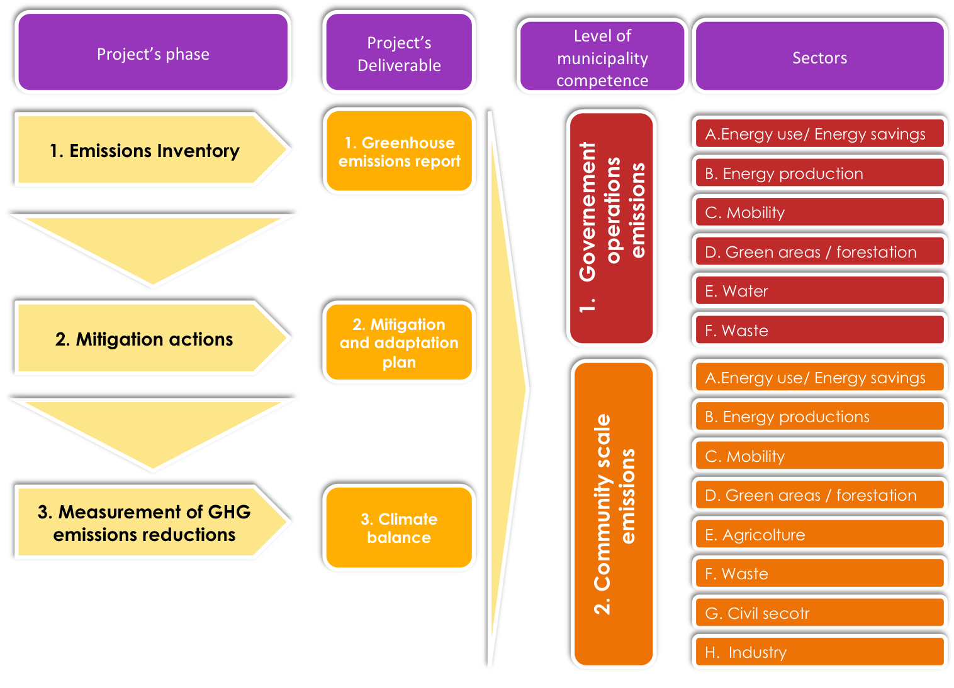
GROUPS TO TAKE INTO CONSIDERATION (FOR A MULTILEVEL GOVERNANCE...The sustainable energy initiatives follow an integrated approach and they are multi-sector, multi-action and multi-level).

1. DEPARTMENTS – UTILITIES – OTHER INSTITUTIONAL ACTORS
2. FOCUS GROUPS (if needed)
3. PARTICIPATION

OUR TARGET TO BE ONLY n .1?

Qualitative Internal Audit Report Summary

Addressing principles:
- Easy questions
- Prepare questions in different sections for direct controlled energy aspects and for indirect e.a.
- Prepare different sections for different issues (buildings ...)
- Involve between conurbation municipalities different political parties

- General informations

- Main competencies of the Municipality on climate change related issues
2.1 Municipality’s competencies (responsibilities, duties) to be described for each sector - department
  - Municipality’s policies

- Technical environmental tools of the Municipality related to climate change
3.1 Planning tools
3.2 Environmental management tools
3.3 GHG Data management
  - Communication and reporting tools

a) General information

ex.
...Population
...Pressures
...Municipality Structure
...Mitigation
…Adaptation
...Main issues
...Consortiums
...Covenant office

b) Main competencies of the Municipality on climate change related issues

Municipality’s competencies

Government sectors | Planning and programming | Direct management | Indirect management (through public bid) | Indirect management (through enterprises in which the government has a shareholding) | Other competencies (to be specified) | No competence | POLICY  Legal obligations to be complied with by the municipality
A. ENERGY
a. Public lighting | X |  |  | X |  |  | Energy Efficiency Plan;  Energy Operational Plan
b. Public building energy efficiency performance | X | X |  |  |  |  | Energy Operational Plan;  Energy Efficiency Plan
c. Private building energy efficiency performance |  |  |  |  | X |  | Energy Efficiency Plan
d. Electricity, heating |  |  |  |  |  |  | Energy Efficiency Plan
B. RENEWABLE ENERGY PRODUCTION | X | X |  |  |  |  | Energy Operational Plan;  Energy Efficiency Plan
C. MOBILITY | X | X |  | X |  |  | Energy Operational Plan ;  Urban mobility plan
D. GREEN AREAS AND FORESTATION | X | X | X |  |  |  | Energy Operational Plan;  Energy Efficiency Plan;  Appendix A of the Building Communal Regulation "Set-ups to protect public and private green areas"
E. WATER CYCLE |  |  | X |  |  |  | Energy Efficiency Plan
F. WASTE | X |  |  | X |  |  | Energy Operational Plan;  Energy Efficiency Plan
G: MOBILITY | X |  |  |  |  |  | Territorial Mobility Management – Telecommuting Plan
H: OTHER

ACCORDING TO THE INFORMATIONS GATHERED IN THE TABLE, ALL RELEVANT STAKEHOLDERS (MUNICIPAL AND NOT) ON GHG ISSUES CAN BE IDENTIFIED, NAMED, INVITED AND AUDITED.

2.2 energy issues within the municipalities documented policies (if existing) otherwise discuss ideas, short description existing in the local political top management of the city about energy related policies and generate a document describing them for each municipality and the conurbation

Check if issues related with energy policies are included into the general urbanistic plans and in other plans

c) Technical environmental tools of the Municipality related to climate change

c.1 Planning tools

Planning tools, that have a relevant impact on GHG emissions:

PADOVA EXAMPLE

- Urban plan (brief description and comment on GHG)
- Energy plan
- Traffic and mobility plans
- Green areas plans
- Appendix A of the Building Communal Regulation "Set-ups to protect public and private green areas"
- Territorial Mobility Management – Telecommuting Plan

Even if they have impacts on GHG emissions, none of these plans include specific GHG emissions reductions targets.
All the instruments are developed internally, it means that the decision making process is handled by the municipality staff.

c.2 Environmental Management tools

As regards to environmental management tools, the municipality has activated the following:
- GPP
- Local Agenda 21
- Environmental budget
- Report on the State of the environment
- Urban Plan
- RIE, Reduction of Buildings’ Impact. This tool has been initially developed by the municipality of Bolzano, and it has then been used by the Green areas Department in Padua.

c.3 GHG Data management

- Is there any GHG accounting System?
- Is there any GHG or Energy working group? (ex Padova has Agenda 21 for Kyoto, a system for environmental monitoring, specifically devoted to account for GHG emission reductions obtained through interventions implemented by the municipality).
- data on GHG emissions for the Body? Years of reference? Bottom up or Top down?
- data on GHG emissions for the territory under municipality jurisdiction? Years of reference? Bottom up or Top down?
- Which are the environmental data currently collected (on a regular basis...)?
(ex. Padova:
- Landscape and natural environment
- Energy
- Industrial risk
- Water
- Air
- Soil
- Radiations
- Noise
- Wastes
- Citizens and Environment)

c.4 Communication and reporting tools

List of the tool produced to communicate and/or to report environmental performances, environmental tools....to stakeholders, citizens, other institutions....

