IEE Project CONURBANT
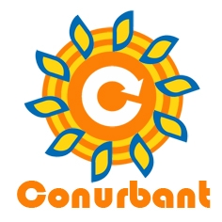

Indicative common template for organisation of the local energy forums
DRAFT
Author(s)
Ekodoma
Arad municipality

January 2012

Contents
Introduction 2
Main tips how to organise successful energy forums 2
What do you need to know to get started? 2
Who do you need to involve in the Forum? 2
How do you promote energy citizenship? 2
How do you ensure that your Forum is a success? 2
What follow-up is needed after a Forum? 2
Main chapters for partners’ report 2
Dates and places of the forums 2
Total number of attendees 2
Sessions of each forum 2
Conclusions of each forum 2
Forum #1 2
Forum #2 2
Forum #3 2
Forum #4 2
Lessons learned and suggestions 2

The sole responsibility for the content of this report lies with the authors. It does not necessarily reflect the opinion of the European Union. The European Commission is not responsible for any use that may be made of the information contained therein.

Introduction
The EU has a significant number of Municipalities that have started a path of sustainable energy action planning and policy-making and propose replicable good practices.
The CONURBANT project aims at helping medium-large cities from seven countries and the smaller towns in their urban area, through capacity building using peer to peer support and training between less and more experienced Municipalities, in the framework of the Covenant of Mayors (CoM).
In development of Sustainable Energy Action Plan (SEAP) it is important to engage main stakeholders. At least one stakeholder from each of the following categories should take part in the participatory process for the definition of SEAPs:
- Representatives of the industrial, agricultural, construction, service and transport sectors;
- Universities, research institutions and energy agencies;
- Policy makers and public bodies in the territory;
- End users, civil society and its associations (trade, professional, consumers, craftsman, industry associations);
- Chambers of Commerce;
- Energy and energy service suppliers, ESCOs;
- Public and private financial actors.
Involvement of the main stakeholders can be done through organisation of local energy forums. According to the requirements of the CoM, the following issues will be considered by the forum:
- Built environment, including new buildings and major refurbishment;
- Municipal infrastructure (district heating, public lighting, smart grids, etc);
- Land use and urban planning;
- Decentralised renewable energy sources;
- Public and private transport policies and urban mobility;
- Citizen and, in general, civil society participation;
- Intelligent energy behaviour by citizens, consumers and businesses.
This report is an indicative common template for the organisation of the local forums. Chapter 1 summarises main tips from previous projects how to organise the forums. Chapter 2 is the template for the report to submit after the organisation and implementation of 4 local sessions in each of the forums (one in each Municipality or group of Municipalities). Each forum session should be divided in three thematic sessions, each one facing one of the issues listed above.
The main objective of the energy forums is to involve the citizens and other stakeholders in the development of SEAP. In the next chapter main suggestions are summarised how to organise successful energy forum. Energy forums should be planned after data in Emission Baseline have been collected for respective municipality. However, in the meantime the forums can be planned. Forums can be organised in the form of the round table discussions or other form at the time when most of the stakeholders can participate (most probably these will be evenings) and appropriate place.

Main tips how to organise successful energy forums
Information below has been summarised mainly from the IEE project BELIEF (now initiative Energy Cities (http://energy-cities.eu)) material “Involve stakeholders and citizens in your local energy policy. Turn over a new LIEF!”.

What do you need to know to get started?
- It takes TIME!
It requires the joint action of different stakeholders all with different interests, needs and time constraints! It is important to take time right from the beginning to meet with organisations that are not directly involved in climate change or sustainable energy management as their involvement in the Forum is very important.
- Create a coordination group
Coordination group of representatives from various departments can be set up within the municipality associating other important stakeholders. Please note that within this group clear leadership needs to be identified from the beginning. It is up to this group to develop a methodology with clear objectives for the Forum.
- Choose an appropriate facilitator or moderator
A Forum can sometimes involve controversial subjects and conflicts amongst members. Forums should clearly address different interests and should not avoid conflicts, but instead try to facilitate the resolution of those conflicting interests by presenting all participants with a clear target – the best solution with both economics and the environment in mind. You can always try to involve Mayor thus stressing the level of importance of the Forum.
- Invitation for the Forum should come from the Mayor
Invitation for the Forum should be signed either by the Mayor or the highest possible person directly responsible for sustainable energy matters in the local authority.

Who do you need to involve in the Forum?
- Think big – do not focus on your usual contacts
There are a lot of organisations that are interested in energy management that are outside the classic energy sector. Forums can aim at promoting local energy citizenship and thus involve a great diversity of representatives who provide experience, knowledge, motivation, imagination and financing power. This way you can try to unite people that normally never meet to discuss energy issues: school representatives, students, lawyers, a theatre group, artists and churches.
- Get decision makers on board
Many communities agree that it is imperative to have decision makers present at the Forum. It often can happen that at first many of the stakeholders are sceptical therefore, it is always important to have a high level council representative present during debates. It is essential that the local authority take the lead in launching the Forum and that there is a strong presence of administrative personnel for ensuring that the Forum is a success. It can also be important to ensure that the local business sector is represented on the Forum, as this sector is often hard to reach on energy and environmental issues.
- Do not forget who your local stakeholders could be!
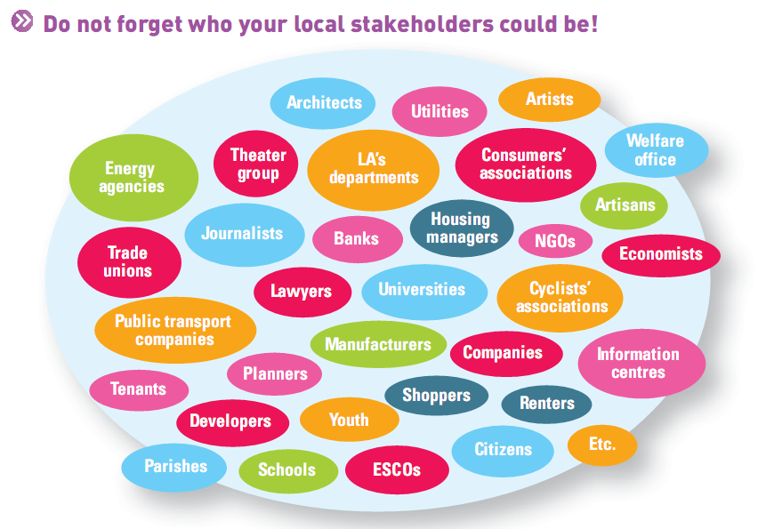
- Associate universities
Universities are useful representatives, as many have research facilities that could be used for monitoring reductions in energy consumption and greenhouse gas emissions.
- Involve NGOs
In general NGOs are the easiest sector to involve in a Forum. The involvement of NGOs in a Forum can have both positive and negative results. The positive aspect is that NGOs, particularly those concerned with “grassroots” activities have good local knowledge and connections with the citizens. However, one of the problems is that they tend to drive away business and even housing associations as they are often very critical. This is an issue that needs to be well managed.
- Invite real practitioners
It is very important to invite builders especially if one of the topics of the Forum is sustainable construction. Many of the municipalities also involve architects and construction companies in their Forum.
- Open to the general public
The general public is often represented by public interest groups and/or representative organisations. However, you should not forget that we are all members of the public and in order to achieve a Sustainable Energy Community we all need to be active. Therefore, in a number of municipalities there have been a lot of focus on involving structures such as sports associations, religious organisations, schools and the general public.

How do you promote energy citizenship?
- Communicate freely
All municipalities organising Forums agree that communication is an essential component to the success of a Forum.
- Take advantage of the media
Due to increasing media coverage the public is becoming more aware of energy issues and therefore, the municipality’s role is to boost this interest by initiating practical projects and interesting initiatives.

How do you ensure that your Forum is a success?
- Active participation is a gauge of quality – the participation of all the Forum members is essential
Try to give Forum members an important role as participating actively is more satisfying than only listening and attending meetings. Or prior to the Forum you can send a simplified questionnaire to the participants with 4, 5 questions asking for identified opportunities and potential solution in order to ensure an active participation and decrease the possibility of theme dispersion. Try not to have too many speeches or monologues. Do not forget that the results of the Forum are dependent on the quality of communication during the Forum.
- Limit the size of the Forum – this is again dependent on the local context
The aim is not to create another talking shop but to be a mechanism for delivery of key actions (thus the link to a sustainable energy action Plan).
- Create win-win situations
The whole aim of a Forum is to increase the participation and involvement of citizens in the development of their territory.
- Keep it simple and personal
Make sure you relate the Forum subject(s) to everyday concerns such as jobs, health and education. Research has shown that people respond better to positive messages that empower local action.
- More coffee breaks please!
Simple aspects such as long coffee breaks and “free time” for discussion are very important. Often this “free time” can be used to organise poster markets (where projects are presented in smaller groups) and other forms of informal exchange.

What follow-up is needed after a Forum?
- Blow your own trumpet!
Everybody needs to be aware about the results of the Forum so that they do not see it as just another place to meet and talk!
- You can always do better!
It is always important to monitor and evaluate your work in order to improve and adapt your Forum activities if needed. You can develop an evaluation form that the coordination group completes after each Forum. The following are some of the questions that you can pose:
- What worked well?
- What should be improved?
- Has the “hardware” (room, equipment, etc.) been well chosen and prepared?
- Have the aims of the Forum been met?
- Has the target group been reached?
- Have the right speakers been chosen?
- Have the right participants been invited?
- Has a balanced involvement of all participants been reached?
- Have measurable results been achieved within the Forum? – What are they?
- Have concrete project ideas been developed during the Forum? – What are they?

Main chapters for partners’ report
Report on implementation of local forums should be finalised until Month 20 (i.e. December 2012) and should describe the results of the four local energy forums held in the Partner municipality and/or Conurbation towns.

Dates and places of the forums
Please list the dates and places were the forums were organised.

Total number of attendees
Please list (in the table below) how many participants and from which organisations participated in the forum. Please make also pictures of each event and place them below.
Number of participants | Organisations
Forum #1
...
Forum #2
...
Forum #3
...
Forum #4
...

Sessions of each forum
Please briefly describe how the sessions of the each forum were selected (NB: each forum should consist of three sessions). Why particular sessions were chosen (were those sectors with largest emissions, potential etc.).
Please briefly describe how you organised the forums. What was the methodology? What was the organisation scheme (main organisers)? Was there cooperation with Conurbation municipalities? How the invitations were made and who signed them? Who was the moderator? How the people react? Were there politicians participating? Did you evaluate the first forums and applied the new knowledge for the next forums? Which stakeholders were the most active? Etc.

Conclusions of each forum

Forum #1
Please list the main conclusions of the first session here.

Forum #2
Please list the main conclusions of the first session here.

Forum #3
Please list the main conclusions of the first session here.

Forum #4
Please list the main conclusions of the first session here.

Lessons learned and suggestions
Please describe and explain at least five lessons learnt and give suggestions what should be improved in organisation of the local energy municipalities.

